<https://pinboard.opera.com/view/72a37025-a1be-48c1-9b40-578828980a46>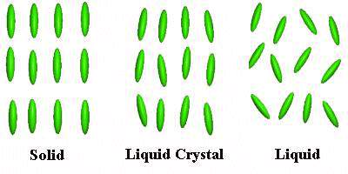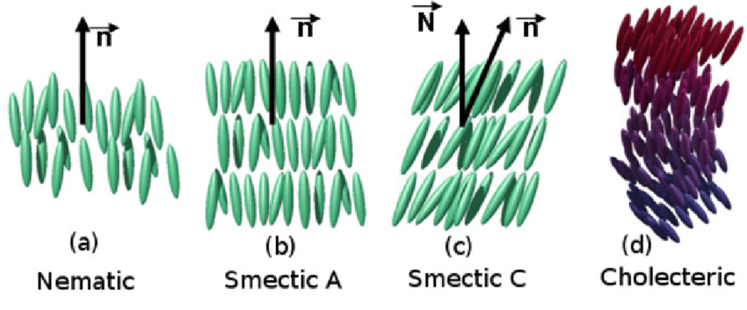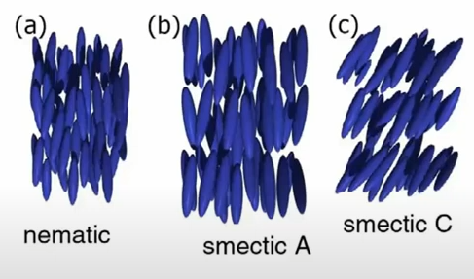

<https://www.researchgate.net/figure/Predicted-phase-diagram-from-computer-simulations-of-a-rigid-rod-system-showing-the_fig5_320146551>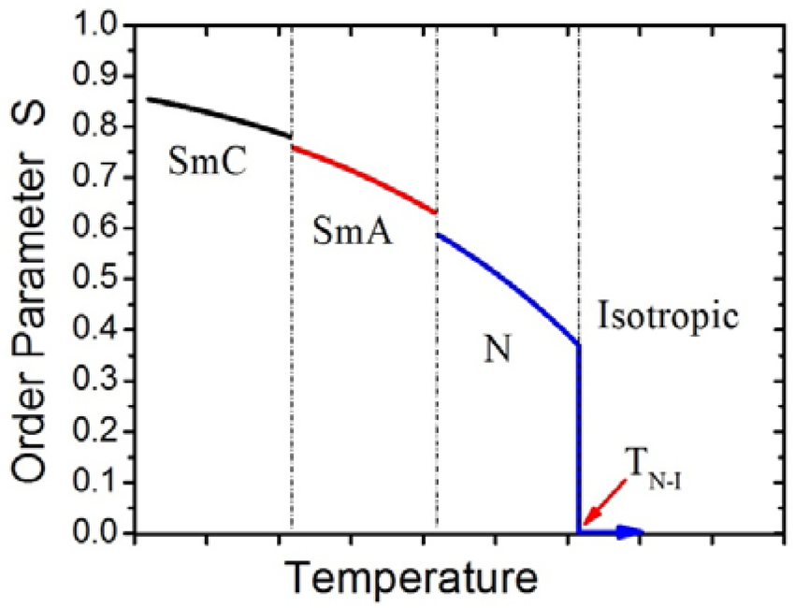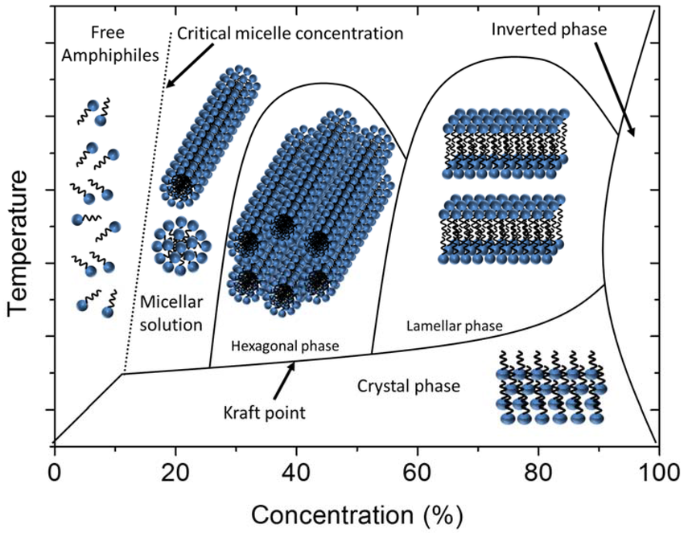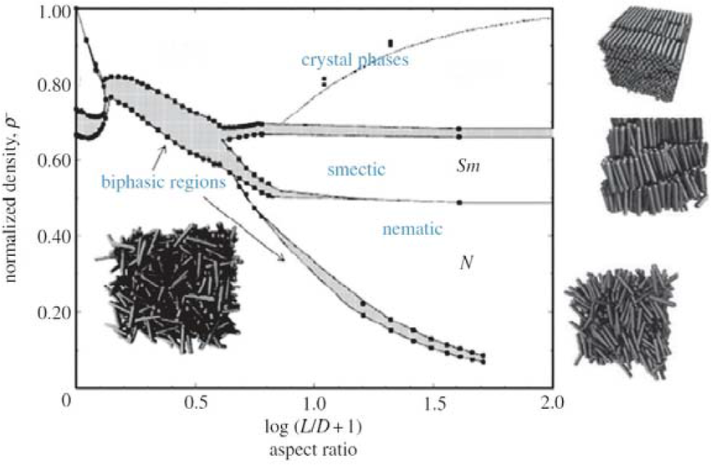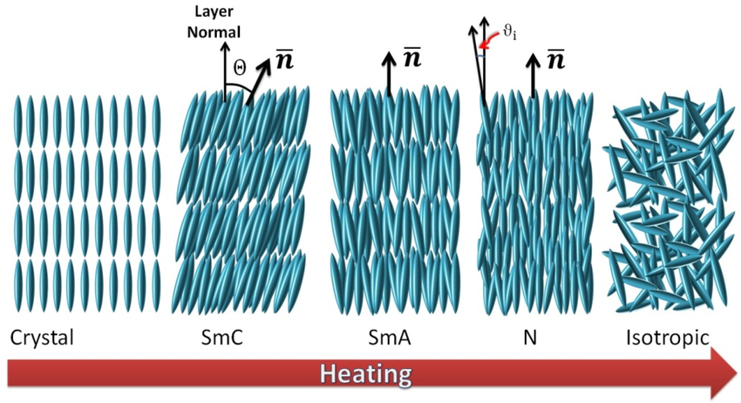

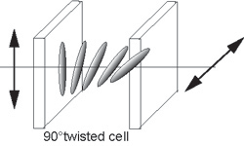

Example of an LC rotating the direction of polarisation

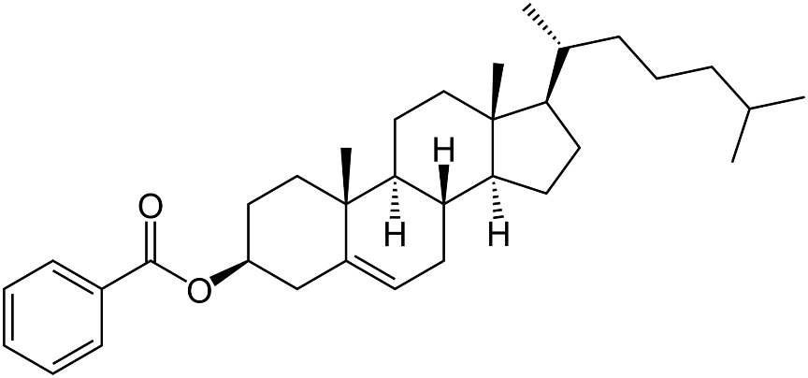

Chemical Structure of Cholesteryl Benzoate